**Question 2**

**Snapshots of creating Users and File**

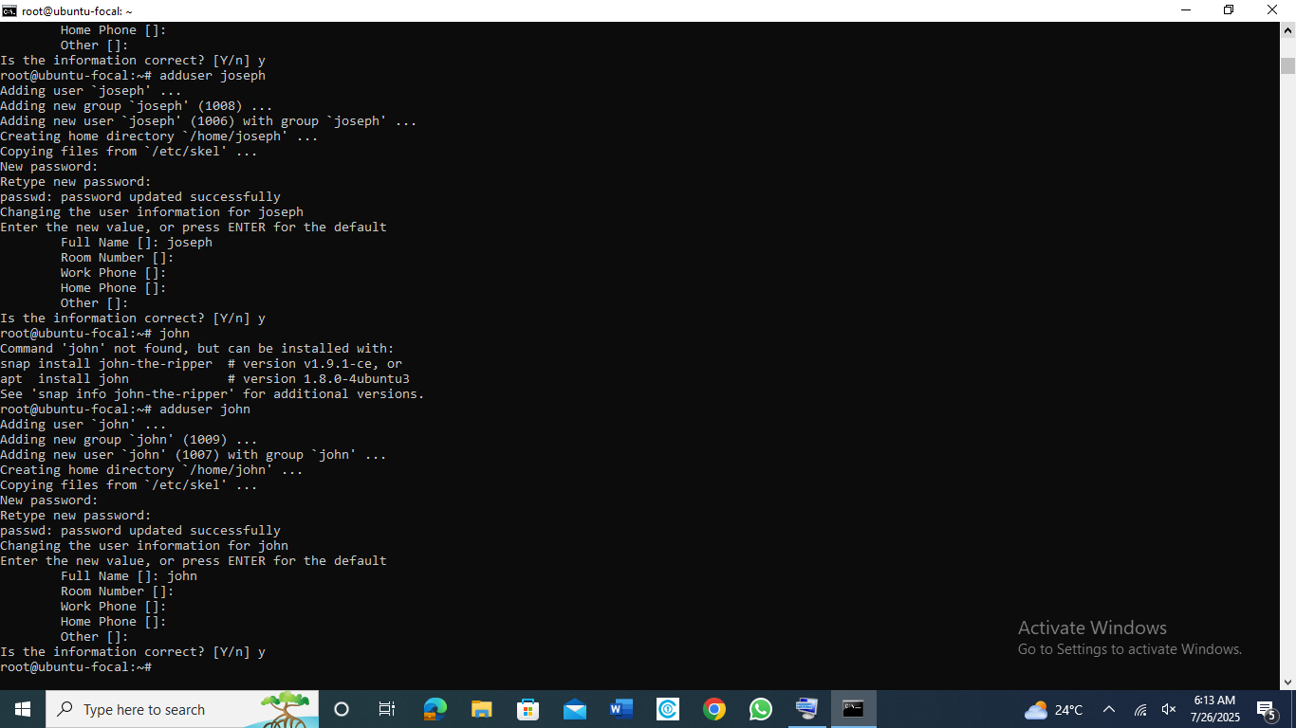

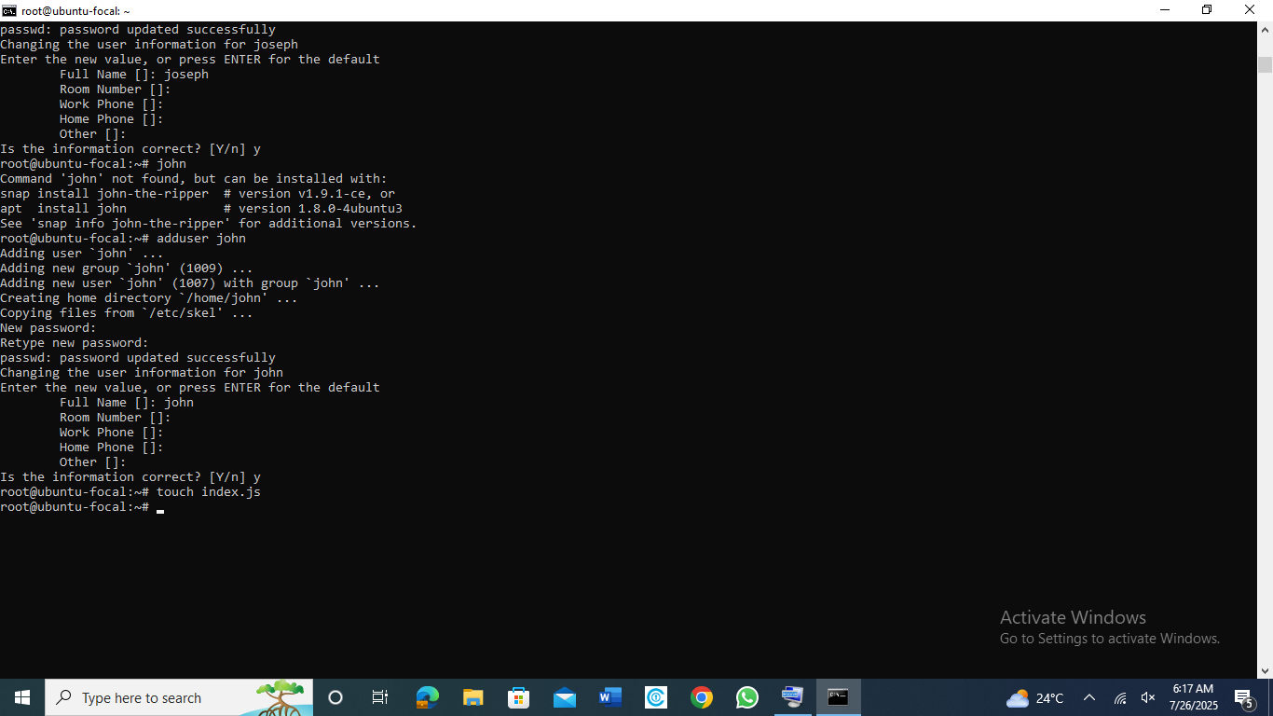

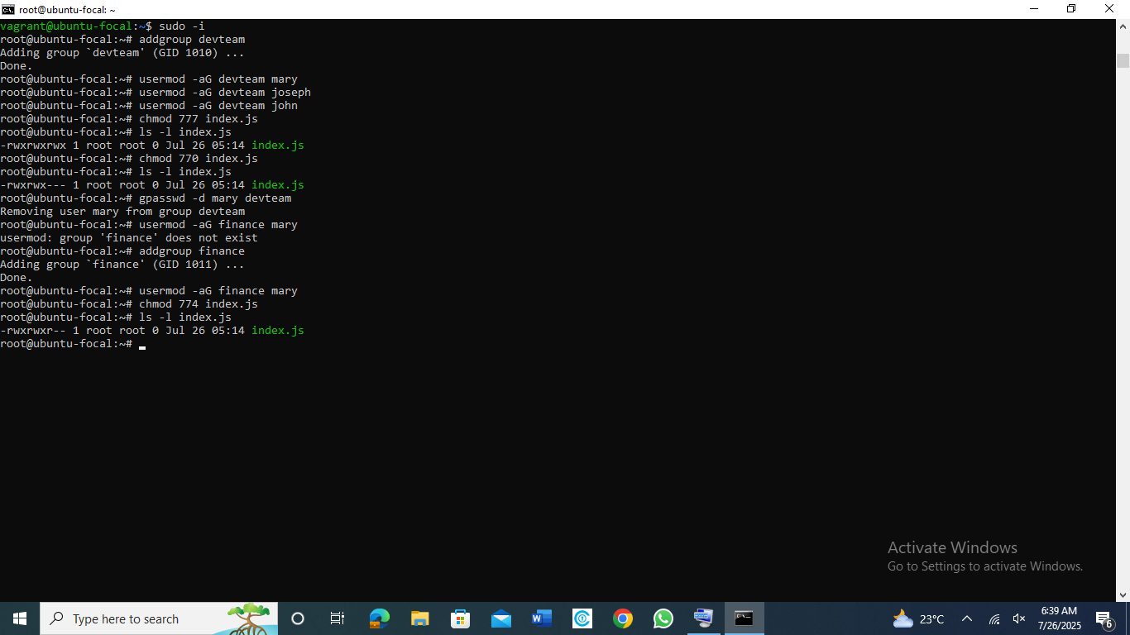

I created three users as instructed, I created 2 groups “devteam and finance”, Mary is in finance with read permission only while Joseph and John are in the devteam group with read, write and execute permissions.